What’s happening in Latin America?

The Latest News from Alliances in the Latin America region
December 2017
Colombia  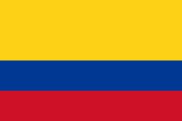 | National Nutrition Status Survey: 2015 Nutrition Survey results have been disseminated by the Ministry of Health. While there has been a slow decrease in chronic malnutrition (around 2%) at the same time overweight and obesity rates are increasing in all age groups. The data for acute malnutrition, shows exponential increase (from 0.9 in 2010 up to 2.3 in 2016) this last result has been contested by various stakeholders, including Civil Society. The Ministry of Health is now revising and validating the data in order to publish the results. The Civil Society Alliance is ready to help scale up the findings of this survey at local level.

More info: National Nutrition Survey results presentation (Spanish)
Contact the Colombia Civil Society for Nutrition
El Salvador  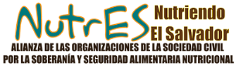 | Documentation of the Human Milk Banks and Collection Centres Strategy: Currently, 3 Milk Banks and 42 Collection Centres have been established nationwide. The milk donated by mothers is given to premature newborns or babies with low birth weight, benefiting more than 2,095 newborns. CALMA, a member of the Alliance NutrES (SUN Civil Society Alliance El Salvador), the Ministry of Health and UNICEF, jointly presented a systematisation report documenting this innovative practice which has had excellent results since its implementation in 2013. This effort has been possible with the support of different sectors, including civil society, who have been working jointly on the strategy since its inception.

More info: Human Milk Bank (Spanish)
Contact the Nutres (SUN Civil Society Alliance)
Guatemala  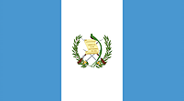 | Joint Planning for Nutrition: A draft multi-stakeholder joint plan to address malnutrition has been developed by Government, Civil Society, and the UN. The final plan is due by early February. Key areas of intervention are related to: the law for school feeding, and its operationalisation and the law on food security which should be approved in the first semester of 2018.

Contact the SUN Civil Society Alliance
Peru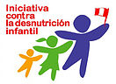 | "Standing Tall": A new World Bank report highlights Peru's success in overcoming its stunting crisis and the key role the Civil Society Alliance played in ensuring that nutrition remain on the agenda across different political parties.
Go to the report
Contact IDI (SUN Civil Society Alliance)
LAC  Regional & Global News | Costa Rica: We are looking forward to meeting Civil Society representatives from Costa Rica to discuss opportunities and challenges in establishing sustainable and dynamic Civil Society Alliances for Scaling Up Nutrition  Global Advocacy: the Latin-American region will be represented by the Guatemala CSA representative at the upcoming ICAN event in February 2018 to share and learn practices on financing for nutrition and working with champions.

Ask for more info (SUN Civil Society Network LAC focal point)

