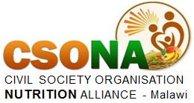

**PROGRESS REPORT ON THE PROJECT; PROMOTING YOUTH PARTICIPATION IN NUTRITION PLATFORMS TO ENHANCE NUTRITION AMONG THE YOUTHS**

**Background**

The Youth Leadership Grant was launched by the Scaling Up Nutrition (SUN) movement with an effort to support and boost capacity of young people’s influence in the fight against malnutrition at nation and global level.

Through the grant, young people who are the Youth Leaders for Nutrition (YLN) were challenged to develop competitive campaigns that can attract funding of up to (GBP) £5000 and the grant holders will be the SUN Civil Society Alliances; their role will be to support youth based campaign in collaboration with the youth champion for nutrition.

The Youth Leader for Nutrition in Malawi was one of the successful candidates to receive funding for the campaign project titled; PROMOTING YOUTH PARTICIPATION IN NUTRITION PLATFORMS TO ENHANCE NUTRITION AMONG THE YOUTHS. The campaign is based on the premise that youth participation in nutrition is very low, despite malnutrition affecting all age ranges. As such through Civil Society Organisation Nutrition Alliance (CSONA) the campaign focused on promoting youth participation in nutrition platforms at all sectors, starting with community nutrition platforms, in order to enhance youth understanding of nutrition and eliminate malnutrition among youths especially adolescents.

The development will advance adolescent nutrition information and strengthen nutrition structures at community level through youth energy, skills, innovation as well as ensuring that young people are recognised at community level as drivers of social behavior change to improve nutrition in the communities. The campaign involved a series of meetings with district nutrition stakeholders to advocate for youth involvement in the nutrition committees and the meetings were also done with the District Youth Officers as well as the district’s youth networks to understand the youth network structures and identify areas where the youth structure can be harmonized with the nutrition structure.

**Introduction.**

This report outlines progress of project activities that were being implemented by the Youth Champion for nutrition with support from CSONA and in partnership with Nkhadze Youth Organisation (NAYORG) in Balaka and Nkhotakota Community Youth Organisation (NYO) in Nkhotakota. The project is being implemented in two districts; Nkhotakota in the central region of Malawi and Balaka district in the southern region. The project targeted two Traditional Authorities (T/A) where there are youth networks and one youth club per each T/A. The campaign project started with advocacy meetings targeting the Directors of Program Planning and Development (DPDs) in the two districts and then meeting with the Principal Nutrition HIV Officers (PNHAO) and District Youth officers (DYO) in the two districts.

The DPD is the chair of the District Nutrition Coordinating Committee (DNCC) and responsible for any nutrition activities implemented in the district. The meetings with the DPDs served as entry points for the projects but also acted as guidance in terms of how best the project can be implemented. The PNHAO are government nutrition and HIV officers responsible for coordination of all the district nutrition activities and their involvement in the project is important, while the meetings with the DYO were to appreciate the structure of the youth network and how coordination of the youths is done from youth clubs at grassroot level to a youth Network at T/A level and District Youth Officer at district level.

**Achievements and Results**

The project has one key outcome which is to **Strengthen Youth Incorporation in nutrition structures at community and district level.** Under this outcome the Youth Champion for Nutrition conducted meetings targeting district nutrition stakeholders, district youth officers as well as interaction meeting with the youth’s networks and the youth clubs. The meetings with the district nutrition stakeholders mapped the way the project could be implemented to achieve the intended purpose. In the two district the DPDs appreciated the importance of the campaign project as it was first of its kind to have a youth- based project in the districts.

The DPDs linked the campaigns to organisations that are doing similar work like AFIKEPO implemented by Save the Children in Nkhotakota district. All the district stakeholders adopted the campaign and agreed that it should be carried out in the district, they also committed support during implementation of the campaign. The project did not form parallel structures to the already established nutrition structures as such this made it simple for district stakeholders to adopt the project. District nutrition stakeholders in all the district advised that the campaign should focus on linking the youths to the Community Leaders Action for Nutrition (ACLANS) and not the proposed Area Nutrition Coordination Committees and Village Nutrition Coordinating Committees as these are technical nutrition structures comprised of expertise paid by government that are at community level.

However, most of the CLANs and ACLANs are dormant because of limited attention by the civil society and government to involve them in implementing nutrition activities. As such, a deliberate effort will be made to revamp the structures, as well as ensuring that the youth have a direct link with the governance structures like ANCC and VNCC. An orientation meeting with the ANCC and VNCC will be conducted to advise them to use the youth in most of the nutrition activities as way of building the capacity of young people in nutrition and increasing linkages between nutrition structures and youth structures. It was also observed that all the districts have the same youth network that runs from the office of the District Youth Network to a youth club at grassroots level. Although the nutrition structure is similar to the youth Network structure and it runs from the District Nutrition Coordinating Committee (DNCC) up until the Village Nutrition Coordinating Committees (VNCC) at village level, there are no linkages between the nutrition structure and the youth networks structure which deprives young people to take a leading role in promoting and supporting nutrition interventions in communities. Other community development governance structures like Area Development Committees (ADC) and Village Development Committees (VDC) are linked with the youth network structure and youths from youth network and youth clubs participate in the ADC and VDC respectively. On the other hand, the decentralization policy and youth policy indicate that young people at each level should be recognised and given opportunity to take part in development on the country through participation in the committees that foster development and nutrition is not left out.

**THE YOUTH NETWORK STRUCTURE VS THE NUTRITION STRUCTURE SHOWING AREAS OF SYNERGIES**

DMEC

District Nutrition Coordinating Committee (FNO, NO, SHN, DCDO, CSO)

District Youth Officer (DYO)

District Youth Network (DYN)

ACLAN with 30 to 50 members ( TA, Counselors, SGVH/GVH, Representative of ANCC)

Area Nutrition Coordinating Committee (AEDC, AEHO, PEA, ACDO, CSO)

TA Youth Network

YOUTH CLUB (GVH)

CLANS with 20-25 Members (Senior/Group Village Headman, Faith Leaders , Prominent People –)

Village Nutrition Coordinating Committee (AEDO, HSA, SHN, CDA)

**8-12 Households per Cluster**

Care Group (8-12 Household Cluster leaders)

Care Group Promoter ( 2-3 care groups)

**CHALLENGES**

The campaign is heavily impacted by COVID-19 as a result of increase in transport fees and limited number of people per gathering that made it impossible to conduct one meeting with all the stakeholders. Due to COVID-19 it is also difficult to meet district stakeholders as government offices are shut down and this required booking appointments which sometimes were not successfully. However, all the responsible stakeholders were met and they contributed their input to the campaign. The increase in duration for the campaign helped to flexibly conduct the activities despite amidst COVID-19. Unfortunately, most Civil Society implementing nutrition activities in the district were not met and phone calls meeting will be done with key CSO in the district to build synergies for the campaign. The campaign requires more funds to thoroughly implement the activities as it is the first time to have a project like this in the district and making joint implementation with other organisation is very difficult. Otherwise activities that are being carried out are likely to be sustained through implementing partners and the district nutrition stakeholders.

**NEXT PHASE OF THE CAMPAIGN**

The next phase of the campaign will focus on training the youth network structures and youth clubs about nutrition and carrying out orientation meetings targeting the ACLAS, CLANS and few nutrition promoters and ANCC and VNCC. During the community nutrition structures meetings, youth will be present and there will be a formal joining of nutrition structures. The last meeting will be done with the director of Department of Nutrition HIV and AIDS (DNHA) to disseminate the finding of the campaign and to advocate for its adoption. Lastly, funds permitting, the campaign will produce radio programs to increase dissemination, especially in the district where the campaign did not focus so that it can be carried out through the whole country. The campaign results will also be disseminated through CSONA platforms like quarterly meetings and CSONA Annul General Assembly so that CSONA members appreciate the campaign and they can mainstream it in their programming.

meeeting
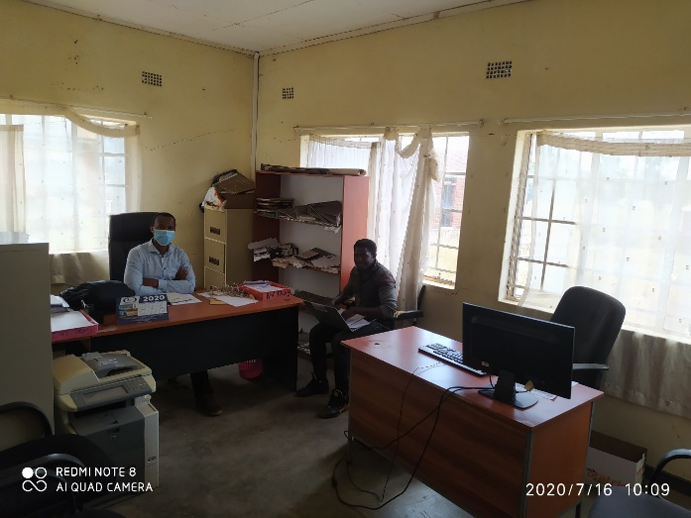

Meetings with the two DPDs; Edgar Chihana and Ben Tohno in Nkhotakota and Balaka respectively.

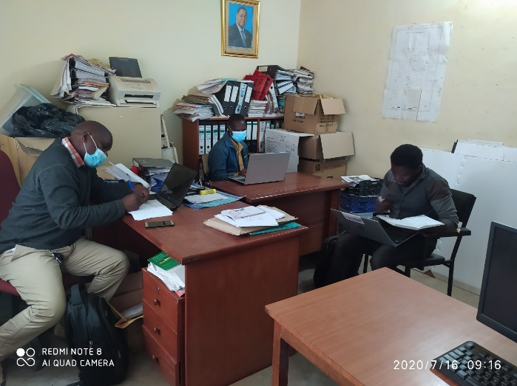 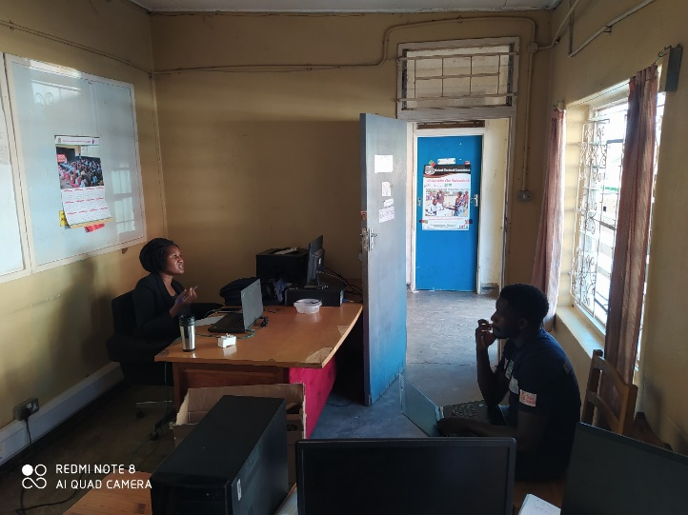

Meetings with the two PNAOs; Davis Kunondo and Dorothy Malamula in Balaka and Nkhotakota

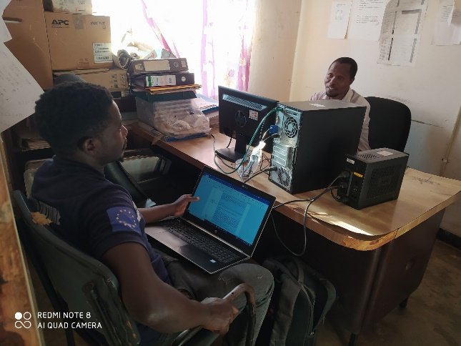 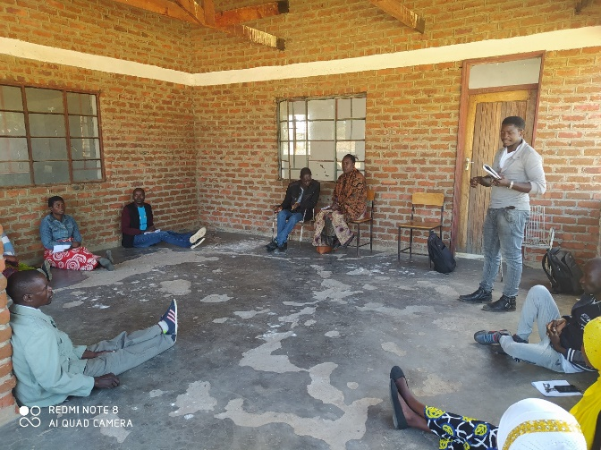

Meeting with The DYO for Nkhotakota, Arbert and an orientation meeting with community nutrition committees in T/A Amidu, Balaka.

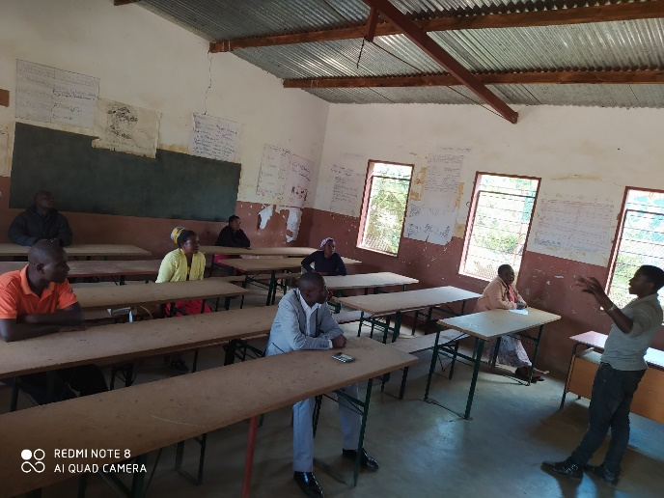 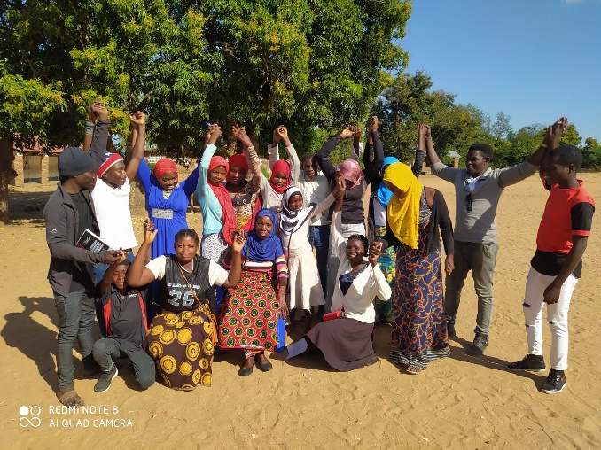

Orientation meeting with the youth network together with community nutrition committee in T/A Chanthunya and Nutrition awareness meeting with Nandolo youth club in T/A Amidu both in Balaka

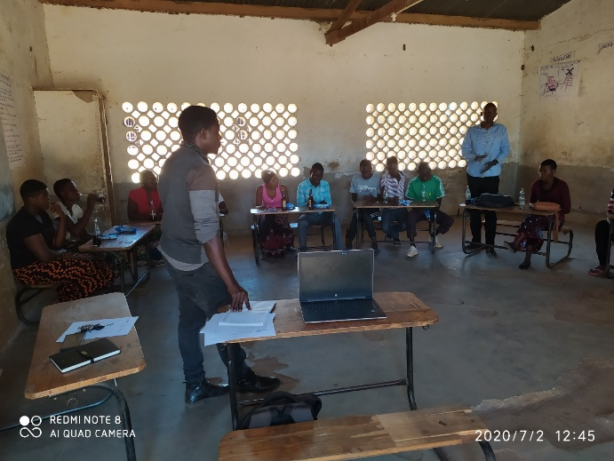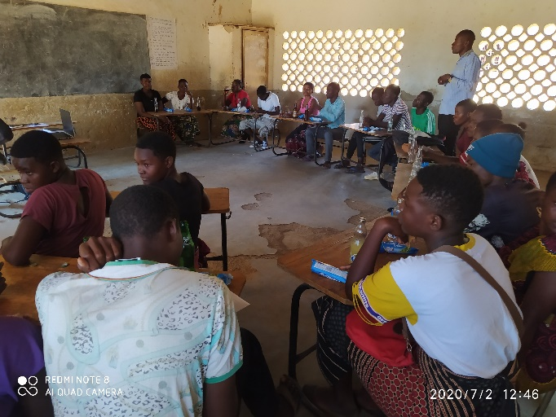

Nutrition awareness meeting with Benga Youth club in T/A Mwansambo, Nkhotakota

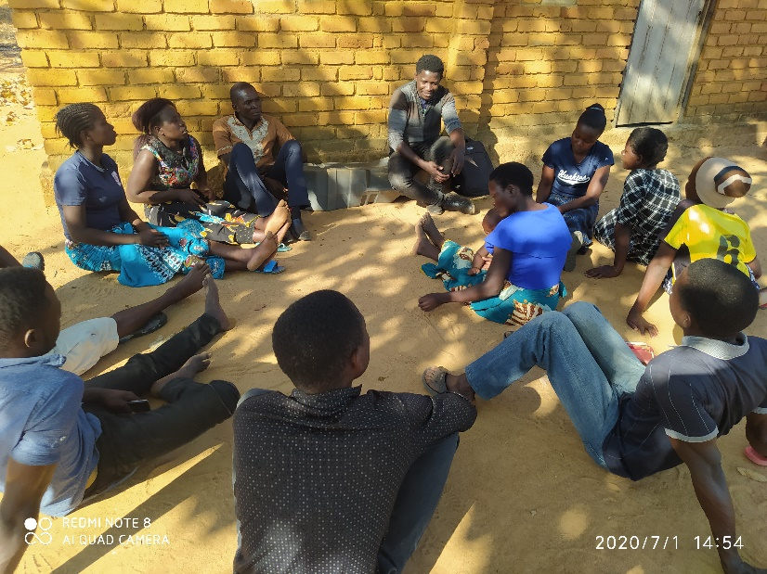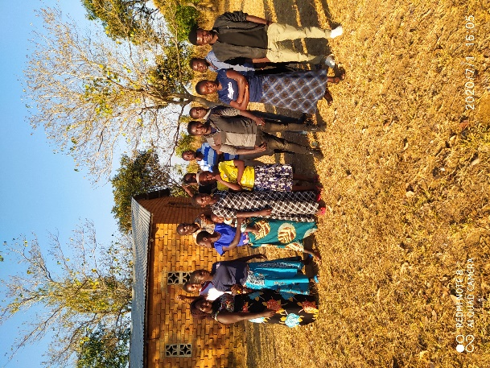

Nutrition awareness meeting with Nalomo youth club in T/A Malengachanzi in Nkhotakota

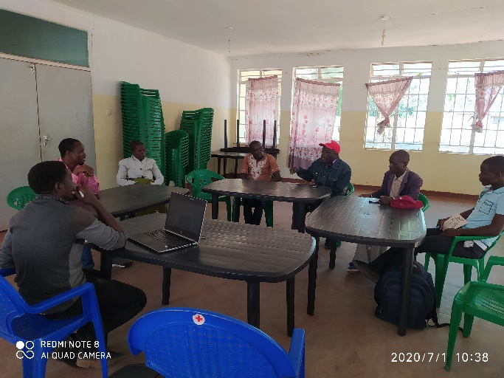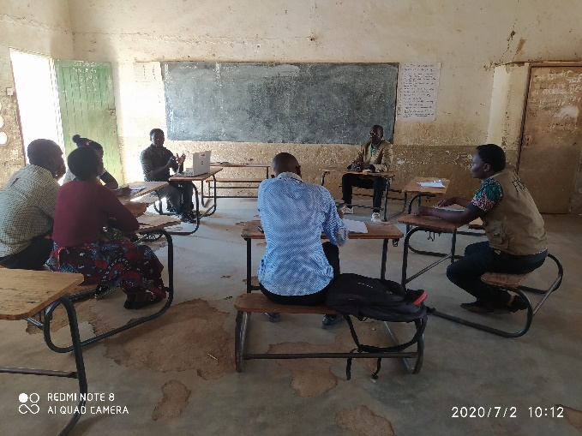

Orientation meetings with community nutrition committees of T/A Malengachanzi and Mwansambo in Nkhotakota

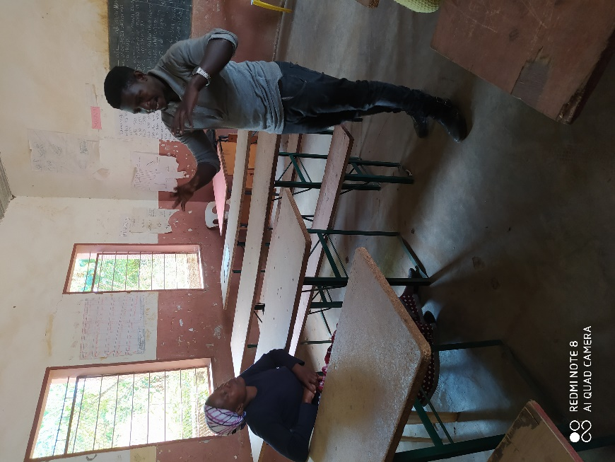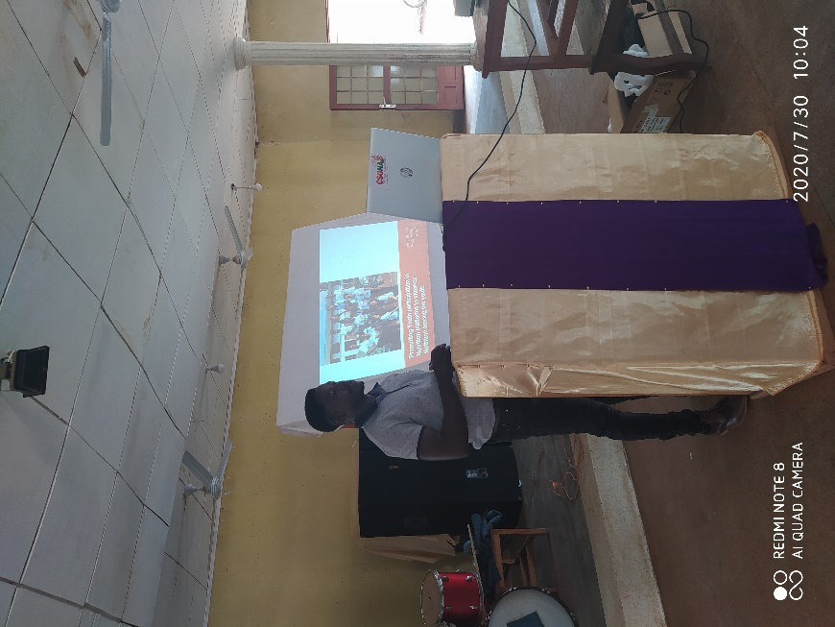

Orienting the chair for ANCC about the role of young people in nutrition and presenting the campaign to Balaka DNCC

**NOTE:**  Some of the pictures were taken before COVID-19 became a serious issue in Malawi.